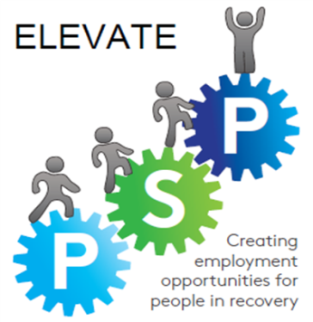
Elevate Glasgow 2018 -2020
Erasmus+ Work Placement programme

Application Form
Italy May 2019

Eligibility Criteria

- You must be currently unemployed
- You must live at a Glasgow City Council postcode address
- You must be in recovery from alcohol and/or substance misuse and been away from the treatment and care of alcohol and/or substance misuse for 12 months
- You must have completed or be currently completing an externally accredited qualification
- You must currently be volunteering and have been volunteering for a period of 6 months
You must be able to attend a Group Selection Interview for the trip on Thursday 14th February 2019 at Glasgow Council on Alcohol (GCA).
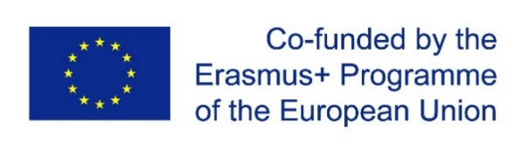

About you
Please return this form by 15th January 2018 electronically to morag@lightonthepath.co.uk and
by post to Light on the Path, R1/72, Berkeley Street, Glasgow, G3 7DS

Name ________________________
Email address ________________________
Phone number ________________________

Postal address __________________________
__________________________
Town __________________________

Postcode ______________

Date of birth ______________

How long have you been in recovery?

Are you currently unemployed?

How long have you been volunteering?

Are you currently undertaking a qualification? YES / NO

If Yes what is it and when do you expect to complete ?

If No when did you complete your last externally accredited/certificated training course?

What training or qualifications have you completed in the past?

Your experience
What sort of experiences in life have you been through to bring you to where you are now? (what’s your story to share?)

Please tell us about your experience of supporting other people, peer mentoring or related support.

What sorts of challenges in life have you helped people with?

What are you involved with just now, in terms of work, volunteering or development?

What other hobbies or interests do you have?

Why you should take part in a European Placement
Please answer the following questions.

- I would love to go to Italy for the work placement because....

- I would be particularly keen to contribute my interests, skills and experiences in...

- I am particularly interested to learn about..

- What kind of work would most appeal to you on your work placement e.g. Catering, Administration etc . N.B. It will not be possible to work in counselling/ advice roles:

- Tell us your vision of how your work placement experience would go.

- How would you expect to share your learning when you get back in your home organisation and further afield?

- What would your dream job be and how would you like to apply your experience in the work placement to that job?

For background and our preparation

Do you have a valid passport that lasts at least until December 2018? Yes/no

What experience do you have of travelling abroad?

Would you be interested in taking part in other development opportunities that might arise? Yes/no

Declaration
Applicant

I can confirm that I have discussed this submission with the person I work or volunteer with currently and that:
- I understand that my involvement is entirely on a voluntary basis, but with all expenses paid.
- I will abide fully with the conditions set out within the Elevate Erasmus+ Guidance for Applicants
Name: _________________________

Signature: _______________________ Date: ________________________

Supporting staff member at support service you have worked/volunteer with

I can confirm that I have discussed this submission with the applicant and that:
- I believe he/she has the right attitude and commitment to gain personal development from the programme.
- I will support the individual in his/her application and in sharing their learning after the work placement if they are successful.
- Both the applicant and I understand that his/her involvement is entirely on a voluntary basis.
Name: __________________________ Position: ______________________

Signature: _______________________ Date: ________________________
Please return this form by 7th February 2019
electronically to morag@lightonthepath.co.uk and by post to:
Light on the Path, R1/72, Berkeley Street Glasgow, G3 7DS

